**Date: 03-11-2021**

1. **TCODE : ZAGMT01 (Critical)**

**Source Type: Bagasse**

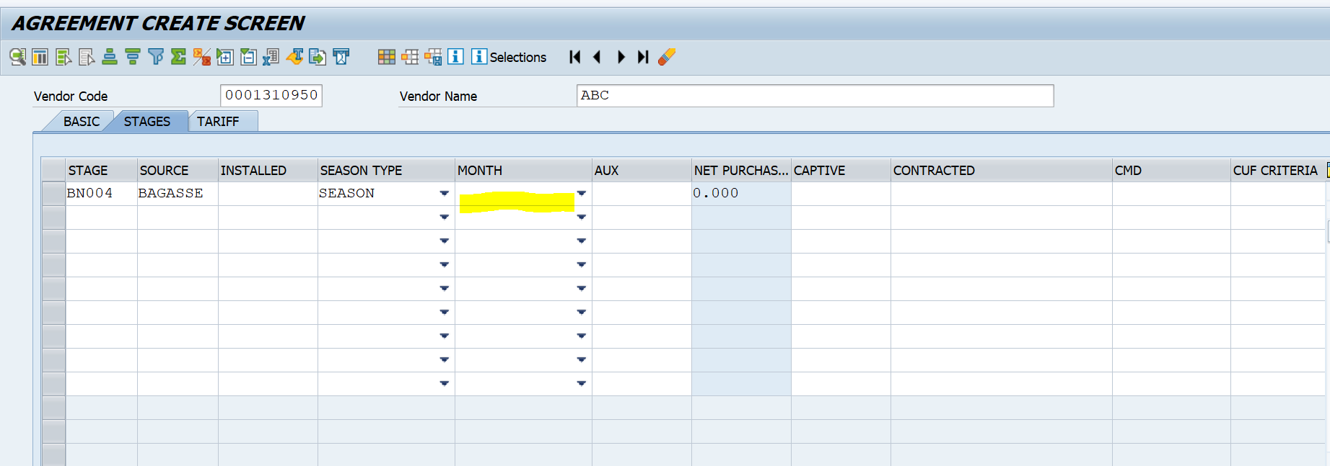

**Add new fields after Season type**

Add a new column called “From Date” <List to show all 31 days>

Add a new column called “From Month” <List to show all 12 month Names>

Add a new column called “To Date” <List to show all 31 days>

Add a new column called “To Month” <List to show all 12 month Names>

The Order of Plant Capacities for **Bagasse**

1. Installed Capacity (MW)
2. Auxiliary Consumption (MW)
3. Captive Consumption (MW)
4. Net Purchasable Capacity (MW) (a-b-c)
5. Inspected Capacity (MW).
6. **Recoveries tab : Reactive, Rebate**
7. **ZCGSMA01**

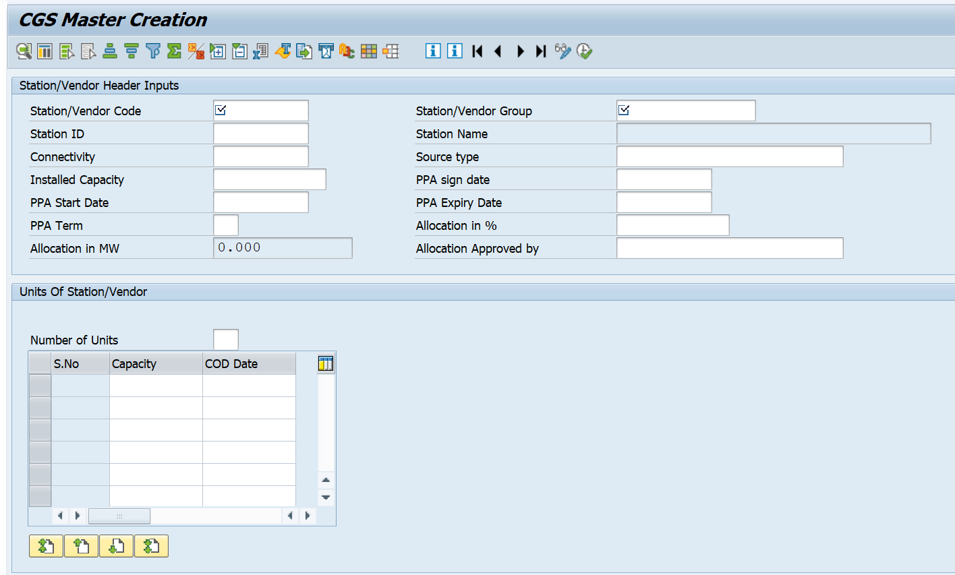

1. First vendor should be entered in zvendor01 and Category as “5100 -CGS”. Only these vendors should be shown in the dropdown of station/vendor code.
2. Rename Station/vendor Code as Vendor code
3. Add a new field called Vendor Name based on the selection of Vendor Code. It’s shown and it’s read only mode
4. Rename PPA Sign date as “Agreement Sign Date”
5. Rename PPA Start Date as “Agreement Start Date”
6. Rename PPA Expiry Date as “Agreement Expiry Date”
7. Rename PPA Term as “Agreement Term”
8. **ZCGSMT01**

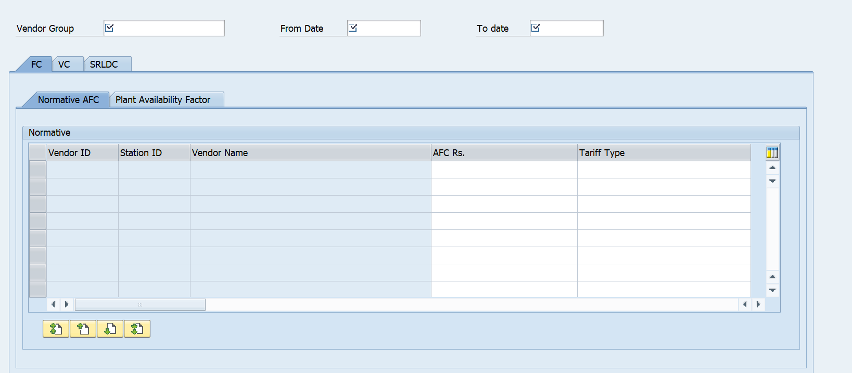

Header Part:

* Vendor Code
* Vendor Name
* Vendor Group

**FC**

* Remove Vendor ID in FC (FC 🡪 Normative AFC, Plant Availability Factor)
* Rename Vendor Name as Station Name (FC 🡪 Normative AFC, Plant Availability Factor)

**VC**

* Remove Vendor ID in VC (VC 🡪 Normative Gross Heat, Normative Aux Consumption, Specific Fuel oil)
* Rename Vendor Name as Station Name (VC 🡪 Normative Gross Heat, Normative Aux Consumption, Specific Fuel oil)